Solving Equations Involving Tangent Lines

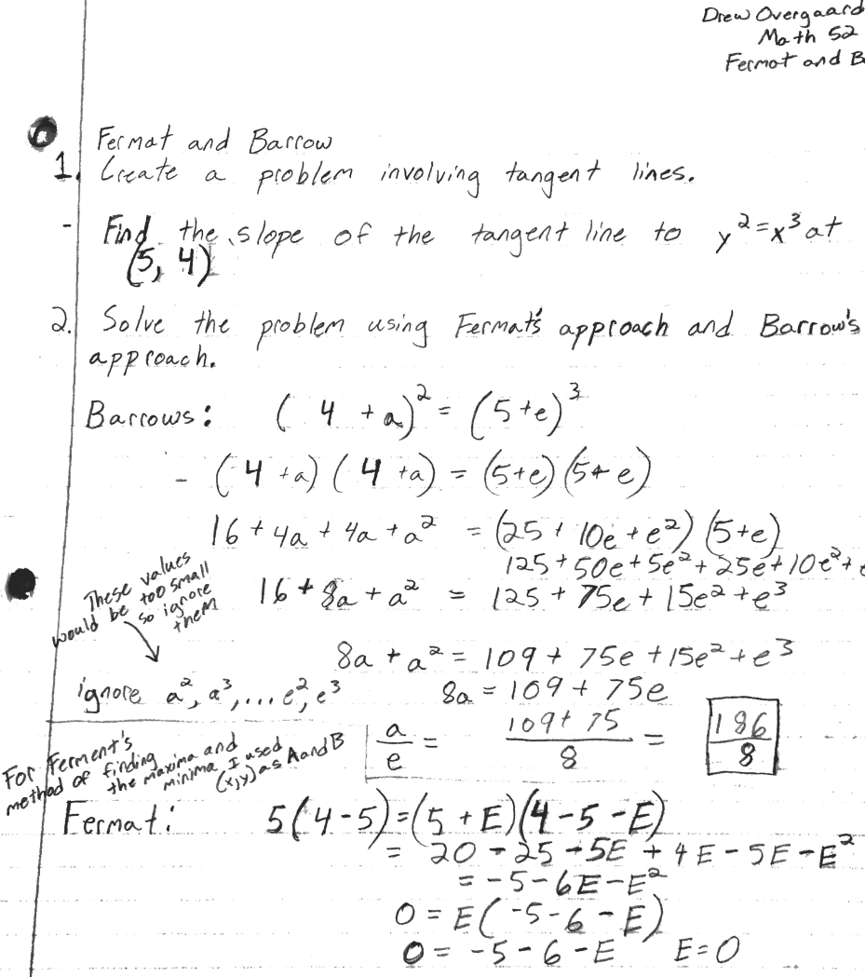

3. I found that Barrow’s method made more sense to me, but I think Ferment’s method is supposed to be simpler. I didn’t really understand how to set up the equation for Fermant’s method, so Barrow’s method was better for me. It is also interesting that when solving the problem using Barrows approach the powers of 2 or greater in the equation are completely ignored because there values are insignificant in solving the equation. For Fermant’s theorem I just plugged in the x and y values from the problem into the A and B values into the method for finding the maxima and minima. I think Barrows method is better because it gives us a value closer to the slope of the tangent line at a specific point.